Eye Gaze & BCI Workshop 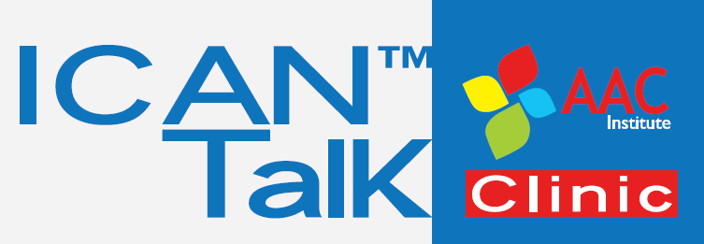
Eye Gaze and Brain Computer Interface AAC: Evaluating Your Options
Saturday, October 25, 2014 • 8:00 am – 5:00 pm
Crowne Plaza Pittsburgh South, 164 Ft. Couch Road, Pittsburgh, PA 15241

Manufacturer Application
Company Information:
Company name: _______________________________________________________________________
Contact: _________________________________ Contact E-mail: _______________________________
Company address: _____________________________________________________________________
City/State/Province/Postal Code/Country: __________________________________________________
Phone: ____________________________ Toll free: ________________Fax: _______________________
Web site: _____________________________________________________________________________

Fees:
_______ $250.00* Manufacturer Registration

_______ $50 for each additional consultant registration (# of additional consultants _______)

$______ Benefit Luncheon donation (Total based on # of guests and donation amount per person)

$______ Total

*Fee includes: Company name placement in Conference print materials and signage, placement of product literature/materials on manufacturers’ display table in Carnegie room (main meeting room); use of 1 conference room assignment for concurrent lecture sessions from 8:30-10:15 am, and for concurrent training sessions from 1:00–5:00 pm with teardown immediately after workshop adjourns at 5:00 pm. Conference room includes digital projector, projection screen and wireless internet access. Registration covers attendance by one consultant/presenter and includes continental breakfast, afternoon break and Benefit Luncheon. Additional consultants may attend the workshop for $50 per person, including the luncheon.

Benefit Luncheon Donation (non-consultant guests per person) please check box and indicate # of guests per donation:
$50 donation _______ $100 donation ______ $200 donation __________
Proceeds from the luncheon will benefit the Ask me why I’m not talking campaign to reverse the CMS Capped Rental Rule.

Want to network after the event? Join us in the Crowne Plaza lounge at the end of the day (cash bar).

Payment: We accept payment by check or credit card.

By check: Please mail this application and a check (payable to AAC Institute) for the total calculated above to ICAN Talk Clinic of the AAC Institute, Attn: Shannon Carney, 1401 Forbes Avenue, Suite 303, Pittsburgh, PA, 15219, USA.

By credit card (4% surcharge for handling): Please complete the credit card information below:

Name on credit card: _________________________________________________________

Credit card number: VISA Mastercard American Express

Exp. ____________

Mail (address above), fax: 412-402-0909 or E-mail completed application form as a scanned PDF file to: scarney@aacinstitute.org Credit card payment will not be processed without an accompanying application form. Questions regarding workshop, please call Shannon at 412-402-0900.

Acceptance:
I, the authorized representative of the above organization, on behalf of said organization subscribe and agree to all terms, conditions, and authorizations.

Payment of $_________ is enclosed. Payment of $__________ has been provided via credit card.

Signature: ___________________________________________________ Date: ________________

This application becomes a contract when signed by a manufacturer’s representative and accepted by the AAC Institute

