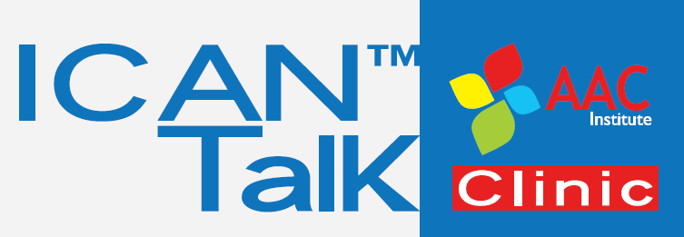

Eye-Gaze and Brain Computer Interface AAC:
Evaluating Your Options
Saturday, October 25, 2014
Crowne Plaza Pittsburgh South, 164 Ft. Couch Road, Pittsburgh, PA 15241

HOTEL ACCOMMODATIONS

Presenters, attendees and additional guests participating in the workshop needing accommodations the night before or after the conference may reserve rooms at our group rate of $119 per night, plus tax.

To make reservations, please contact Cathy Matko, Crowne Plaza Pittsburgh South, Sales office at: Tel: 412-833-5300, x7228 or online Crowne Plaza online using the link below:

http://ichotelsgroup.com/redirect?path=rates&brandCode=CP&regionCode=1&localeCode=en&GPC=EYE&hotelCode=PITSO&_PMID=99801505

